**Robot Framework Using Python Selenium**

* **Robot Framework** is a generic test automation framework for **acceptance testing.**
* **Acceptance test-driven development (ATDD).**
* It utilizes the **keyword-driven testing approach.**
* Provides test libraries implemented either with **Python** or **Java**, and users can create new **higher-level keywords** from existing ones using the same syntax that is used for creating testcases.
* Not much programming is required.

Robot framework required software details:

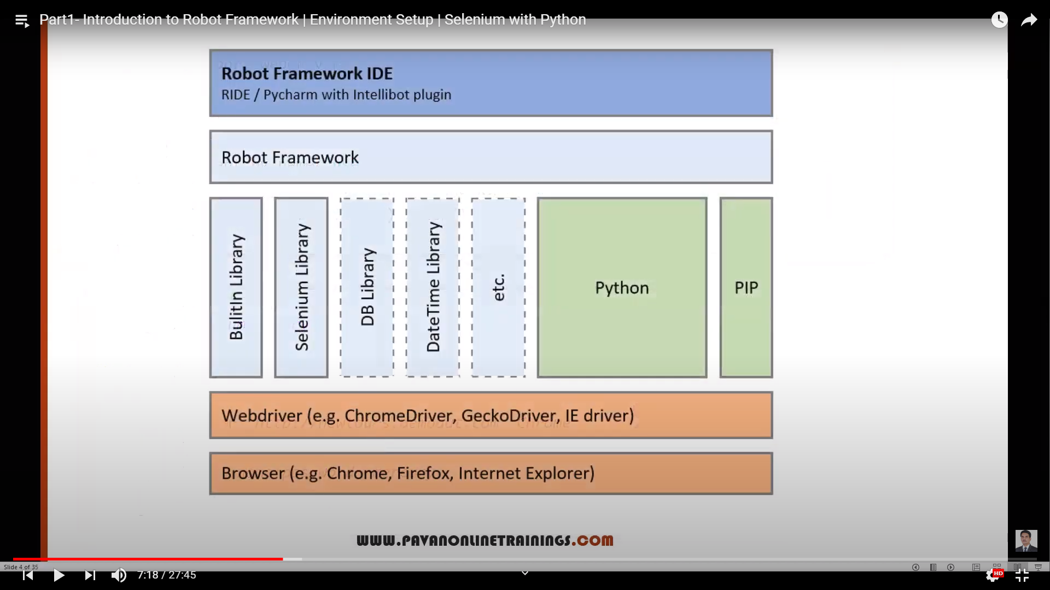

**SetUp:**

* Install Python
* Install Pycharm IDE
* Install Selenium
* Install Robot framework
* Install Robot Framework selenium Library
* IntelliBotSelenium Library plugin for Pycharm IDE

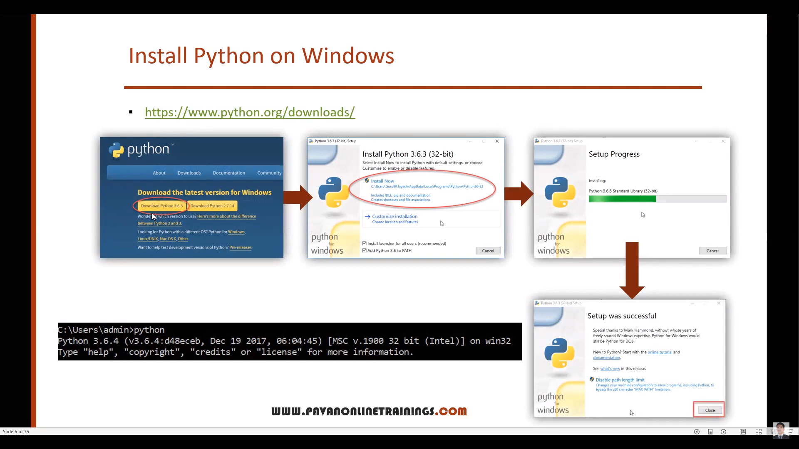

Check python - -version and pip - -version

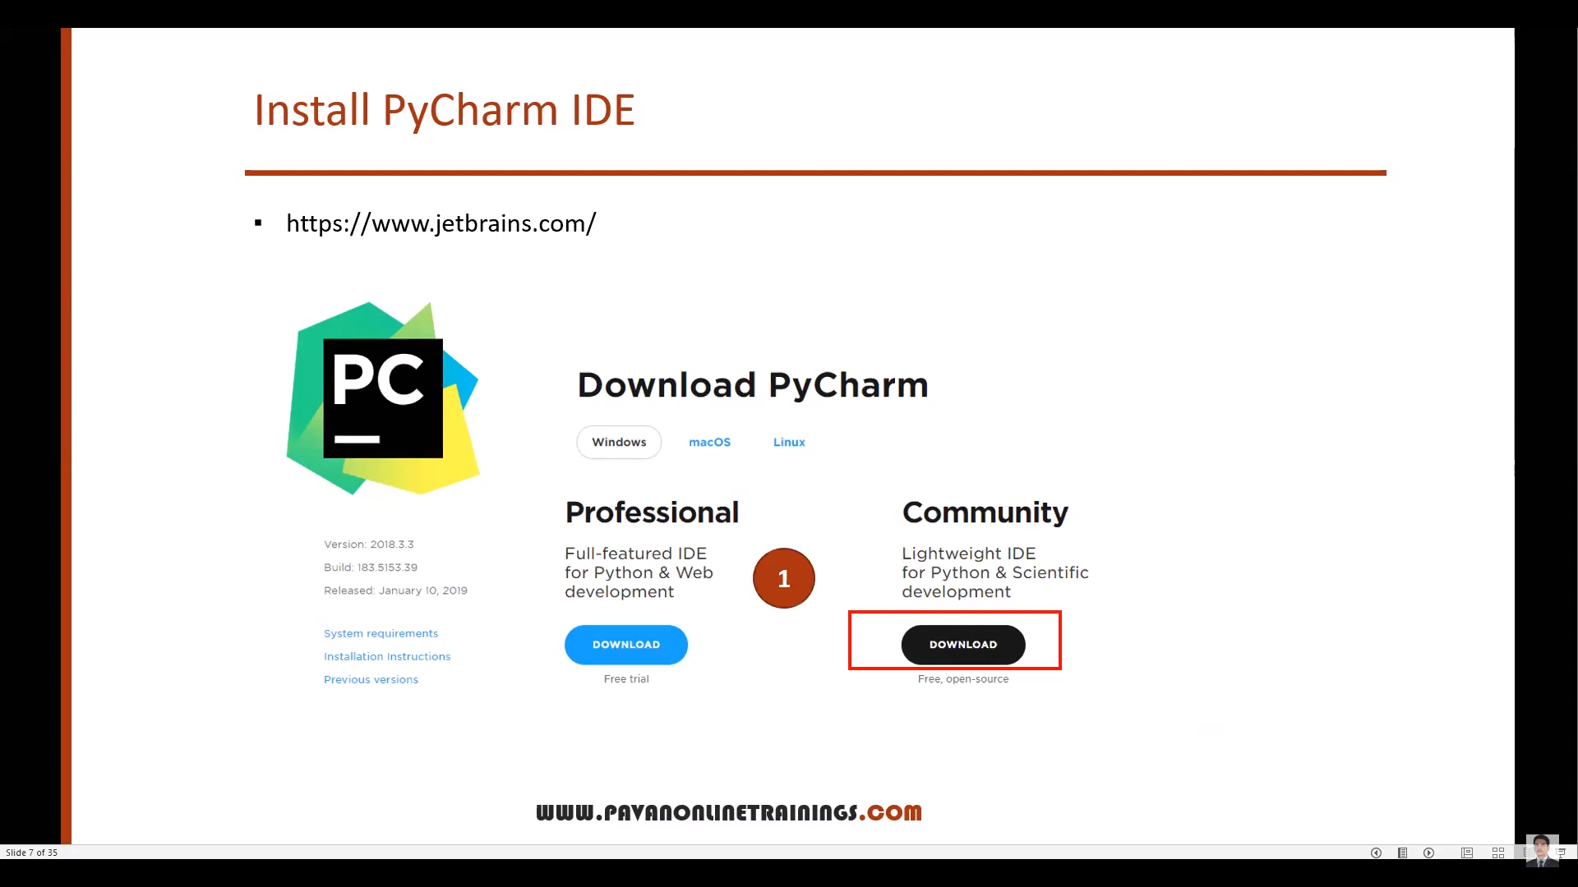

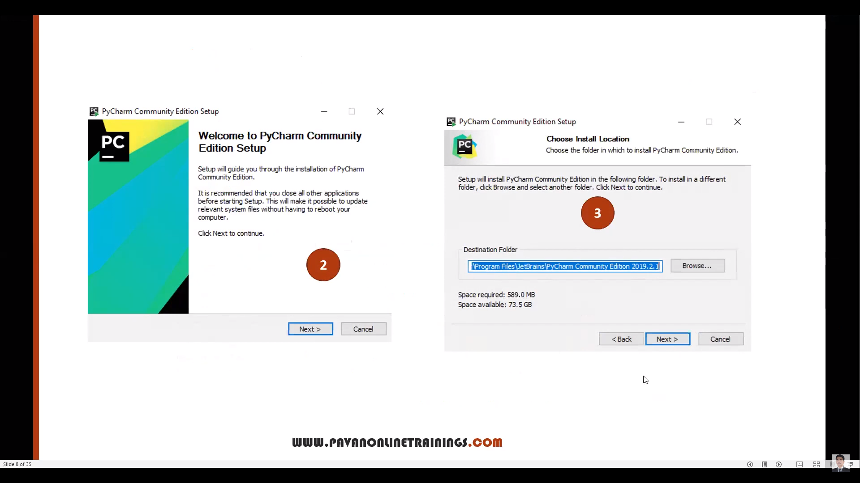

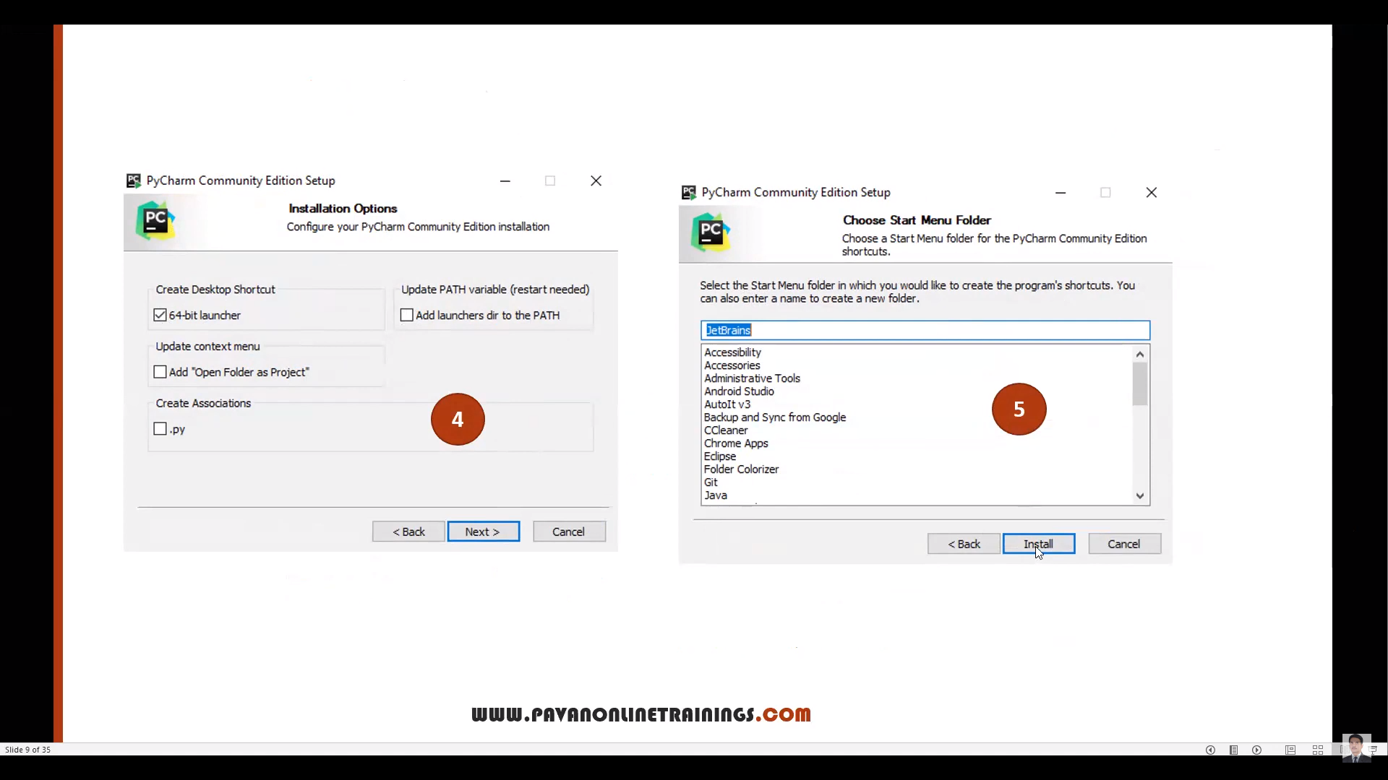

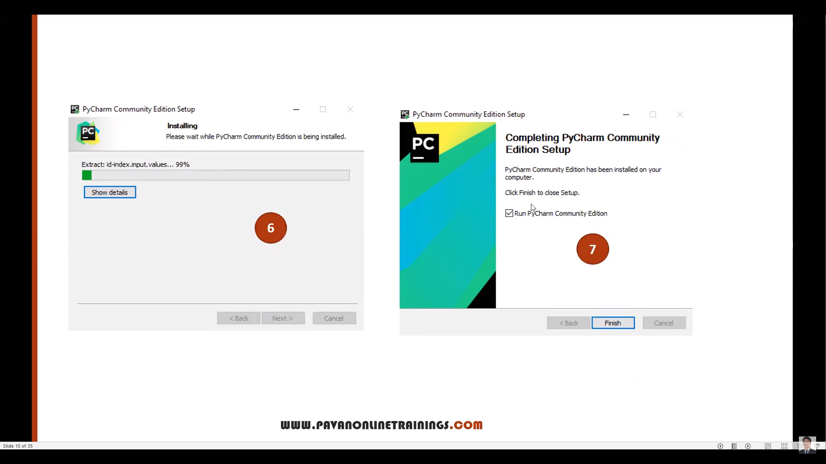

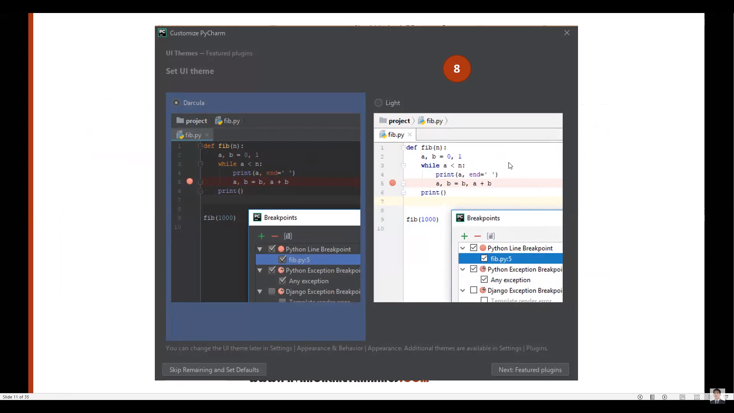

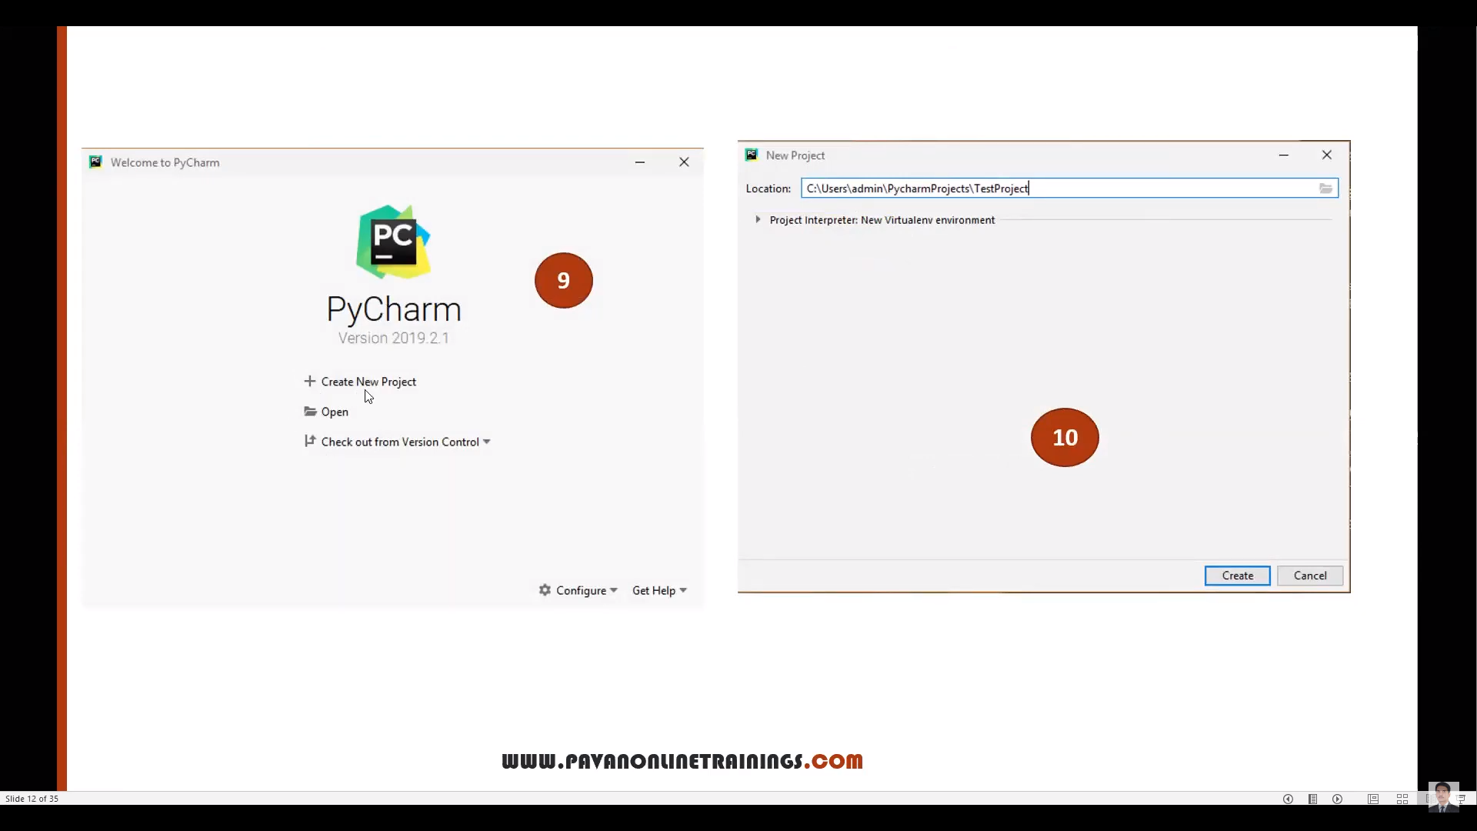

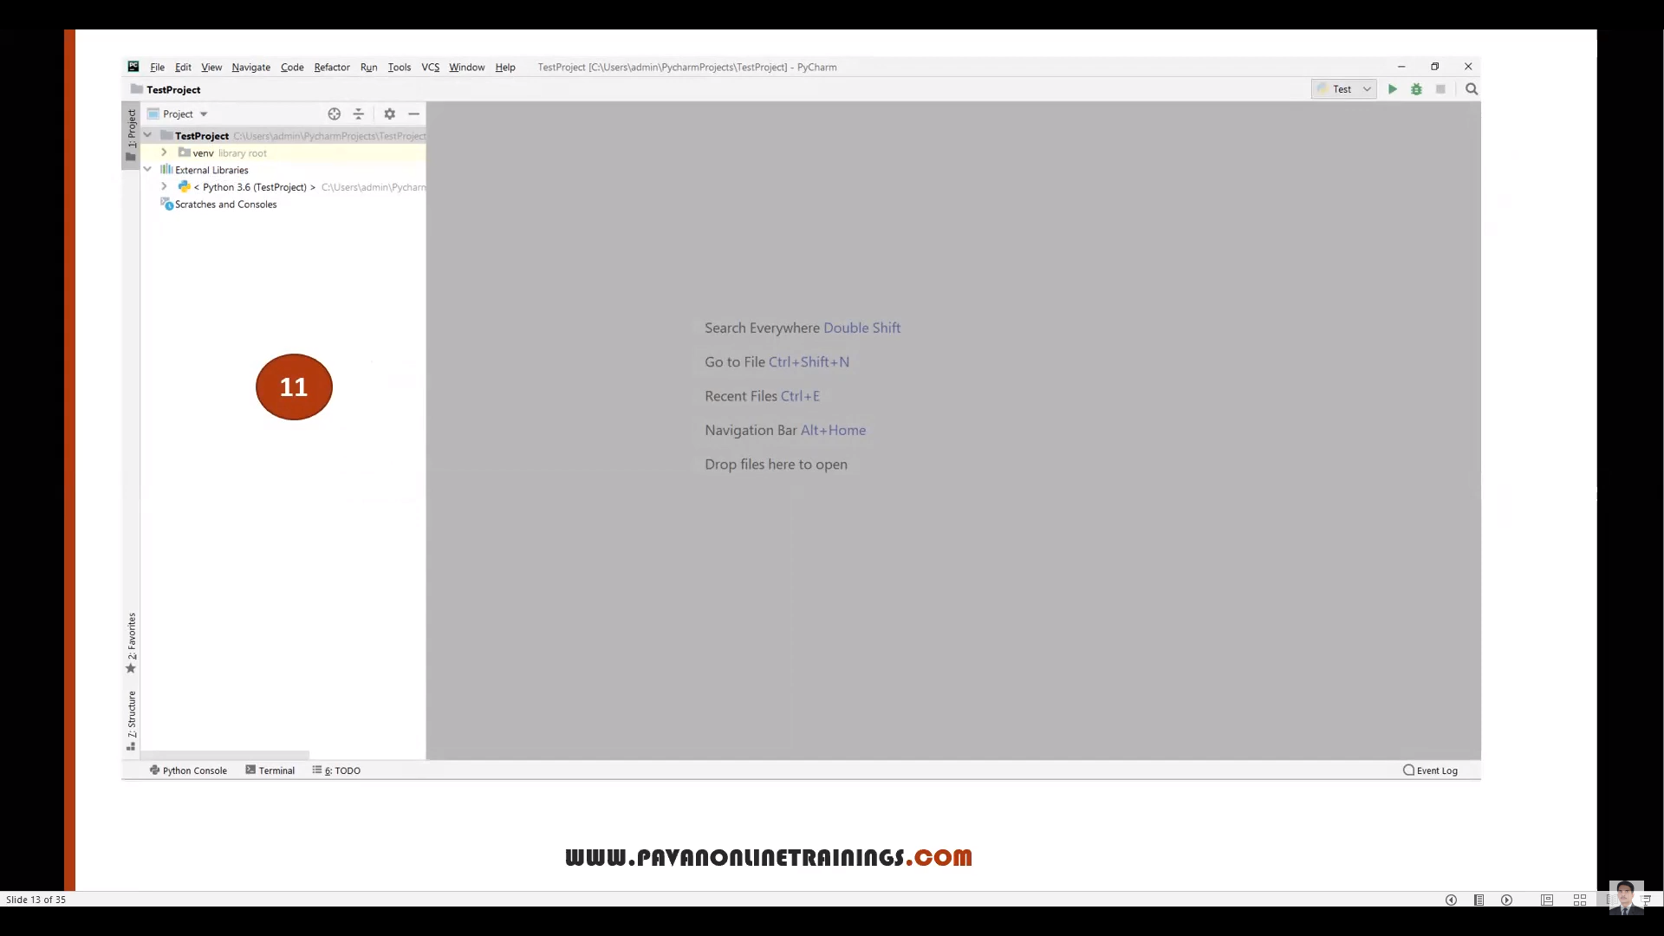

Pre-Requisites:

Python –version and pip –version

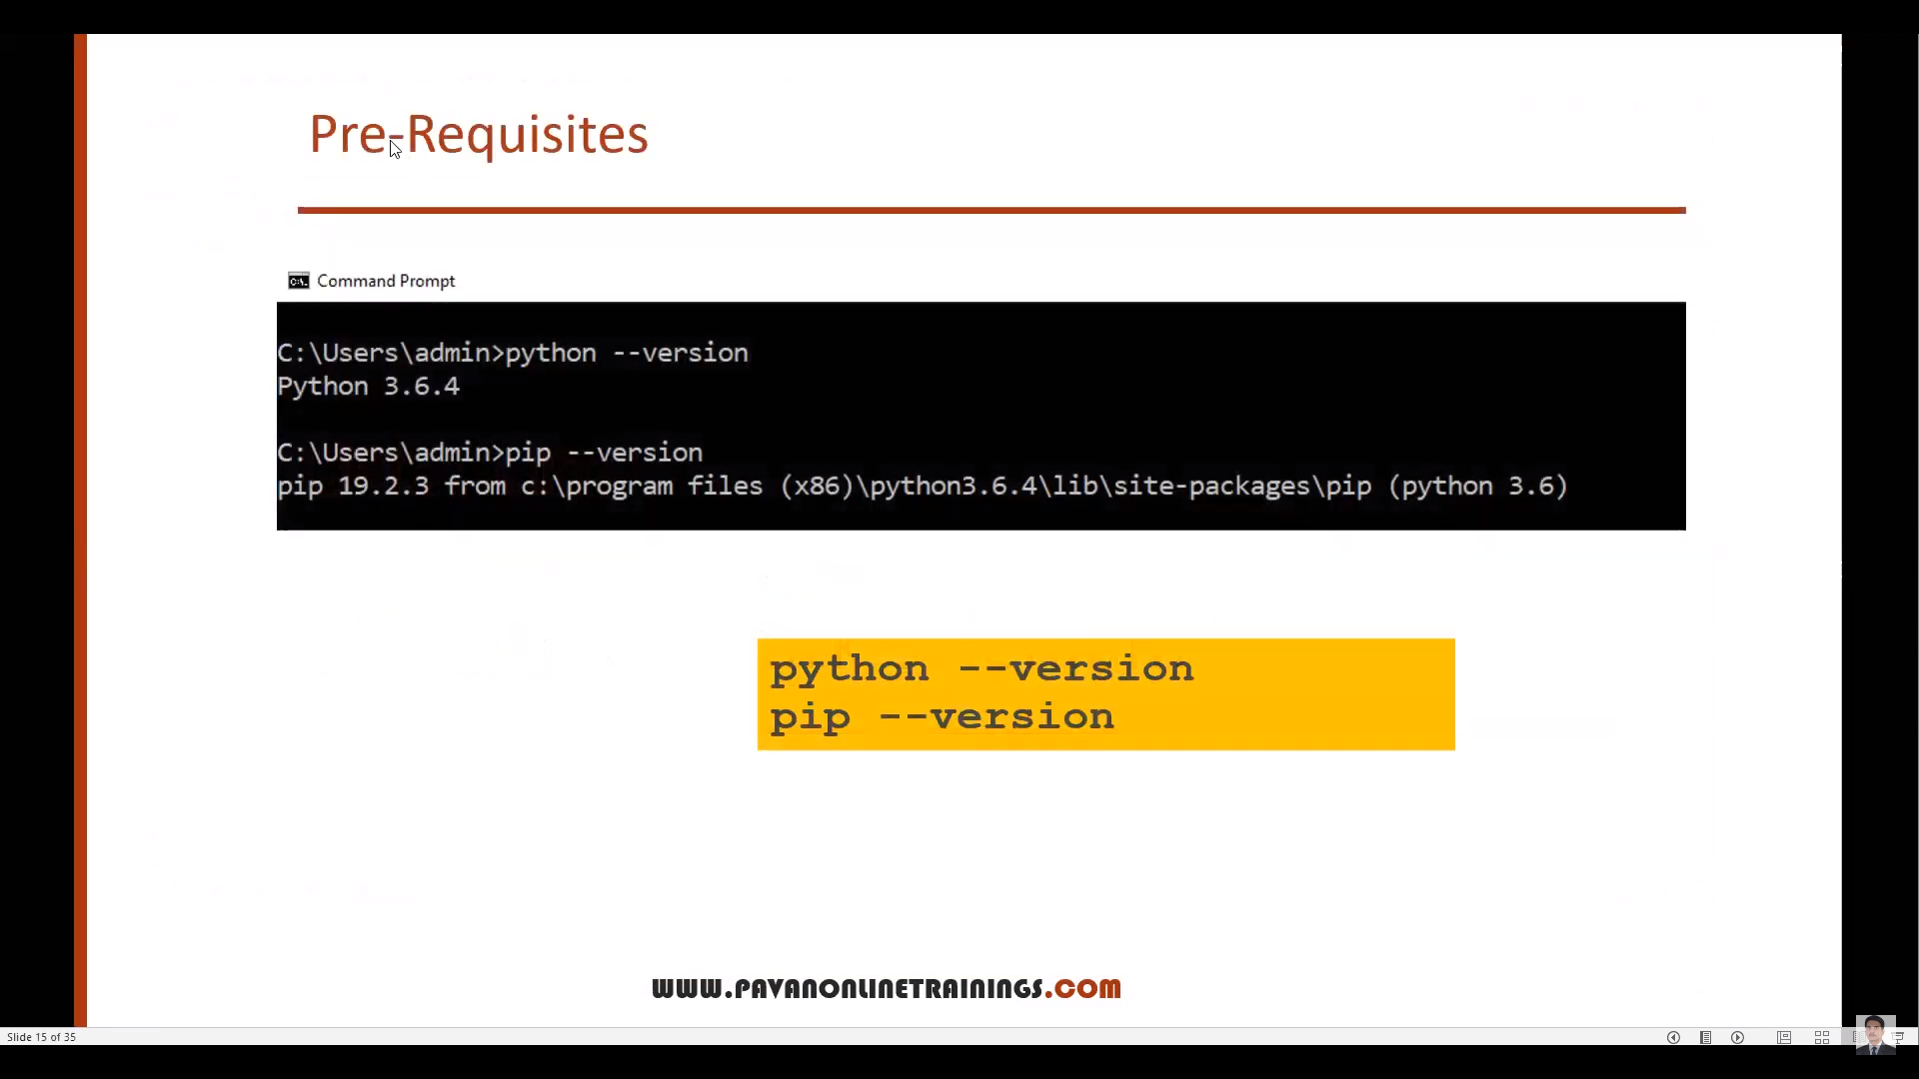

Install Selenium:

Pip install selenium/ pip uninstall sellenium

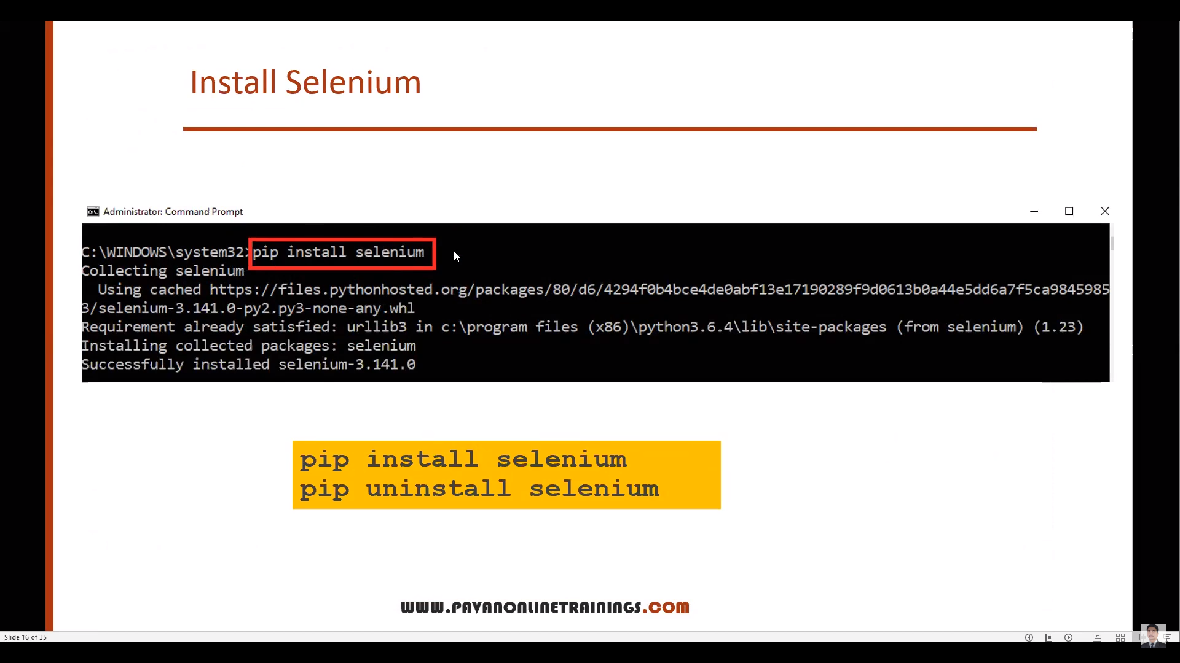

Install Robot Framework:

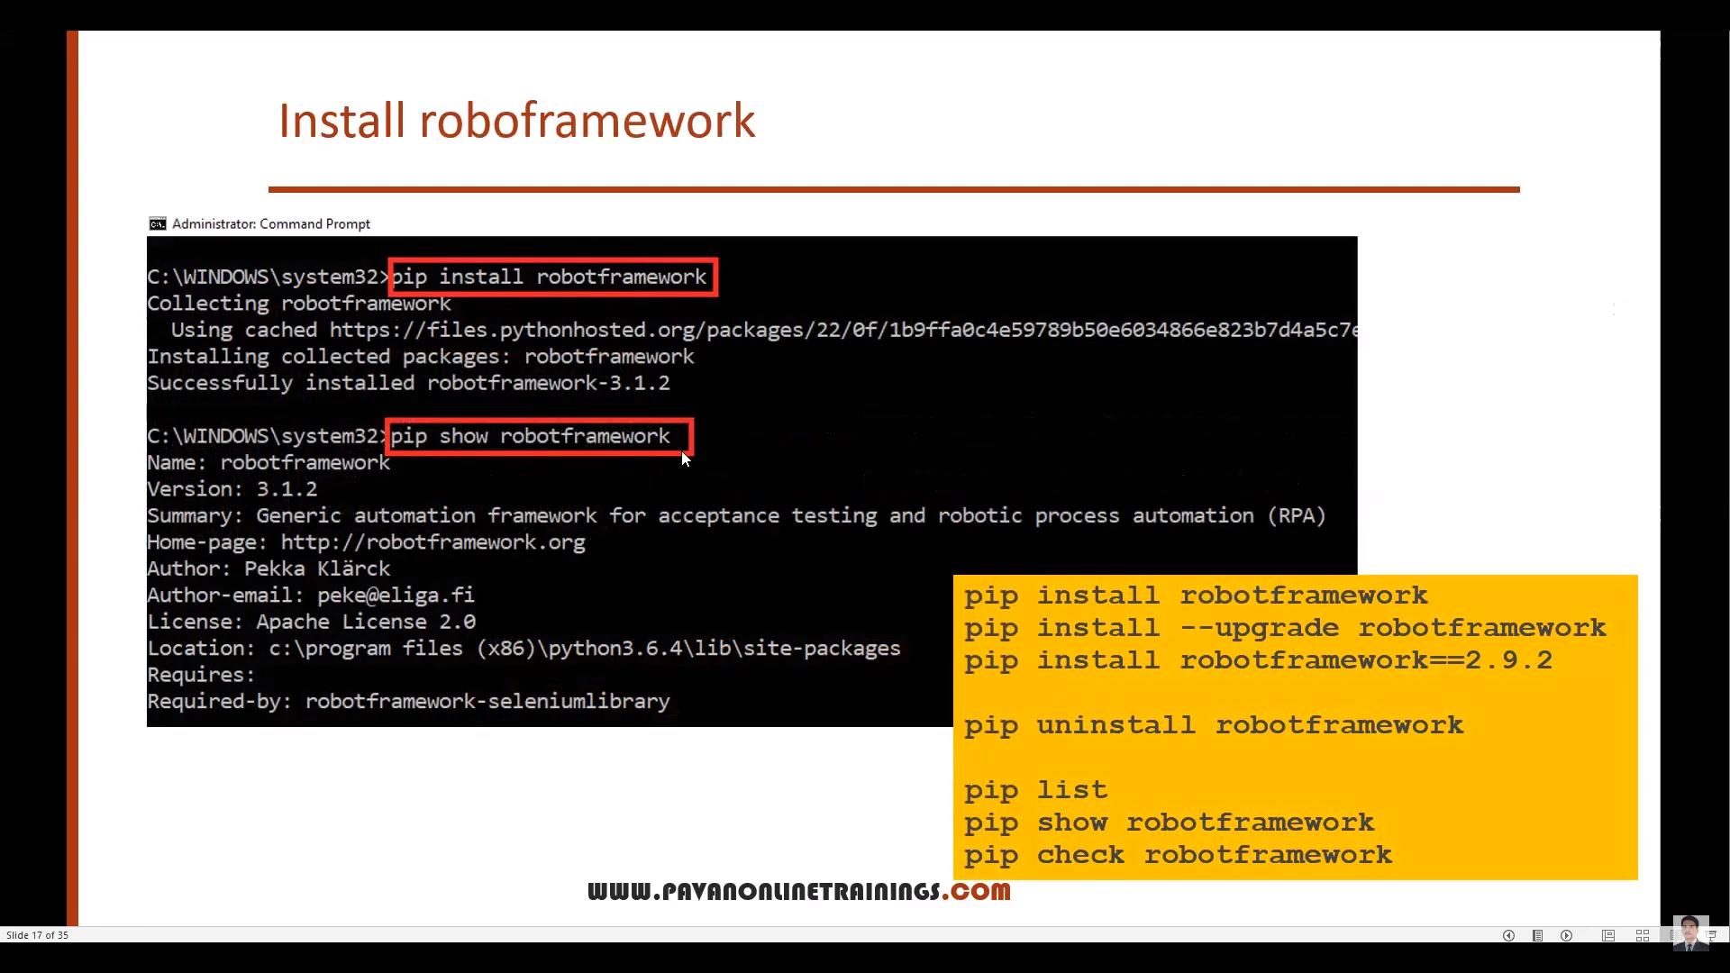

Install RobotFramework Selenium Library:

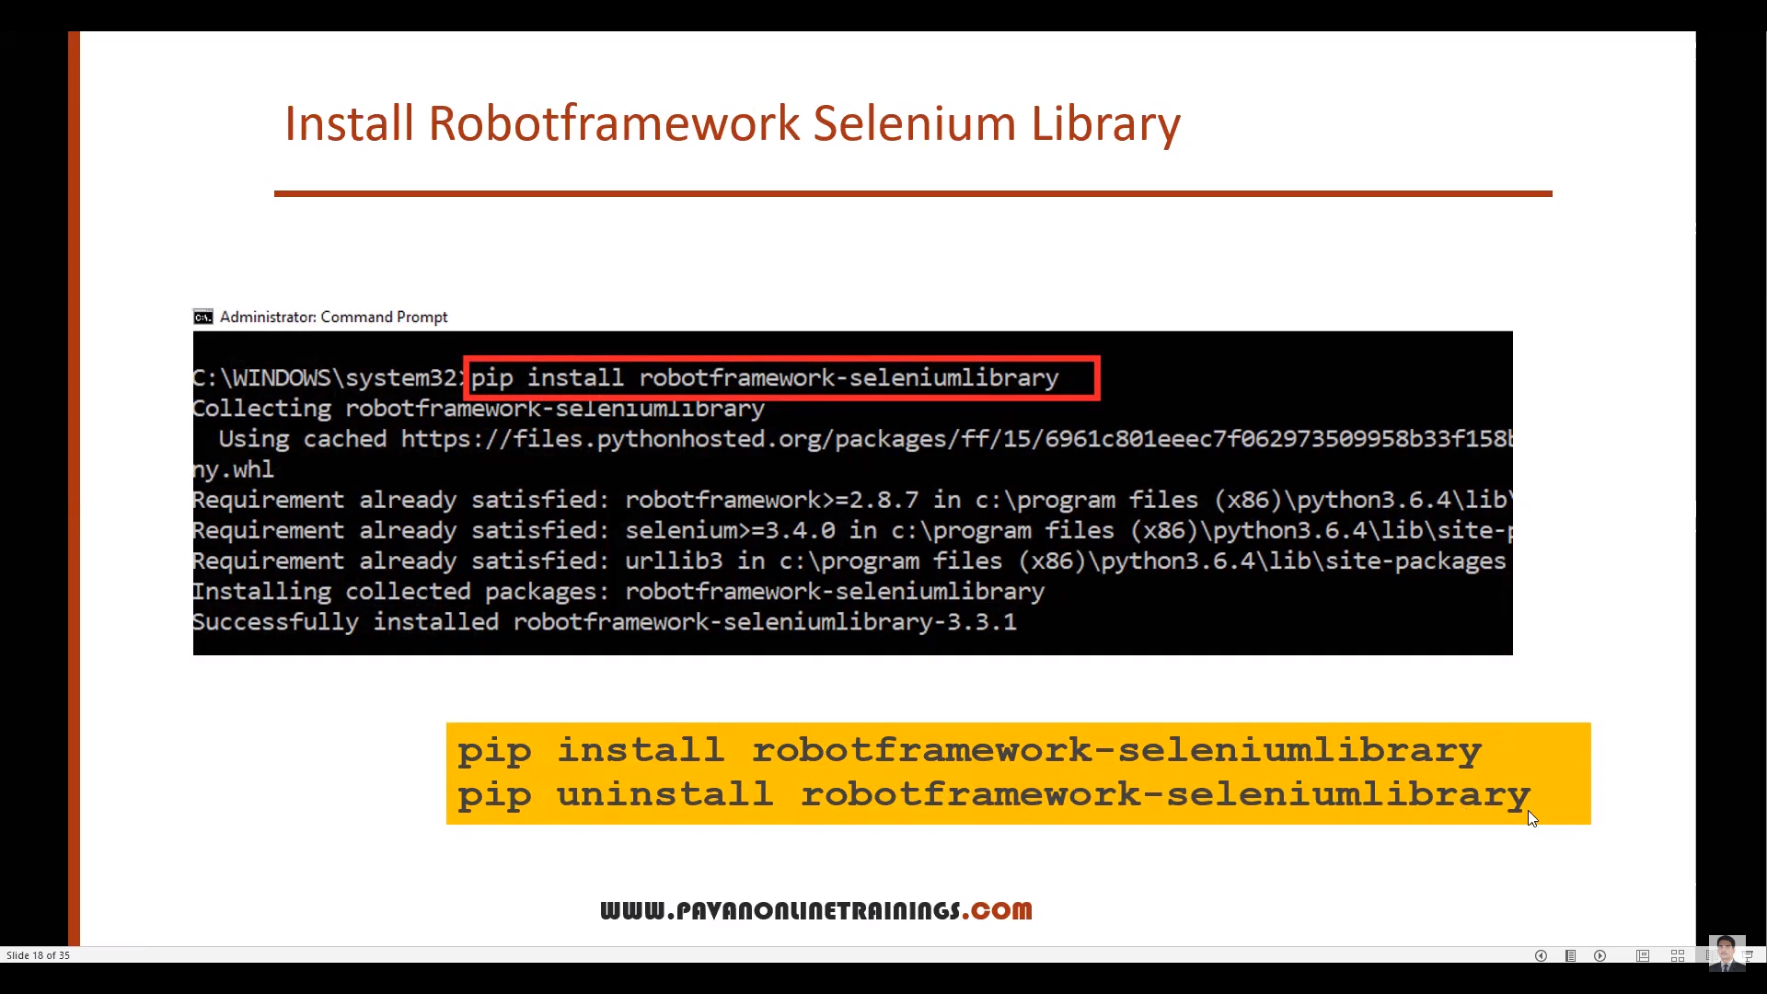

Call all libraries into pycharm IDE in your project:

File 🡪 Settings 🡪 Projec(Name of project) 🡪 Click on + and install all libraries below mentioned.

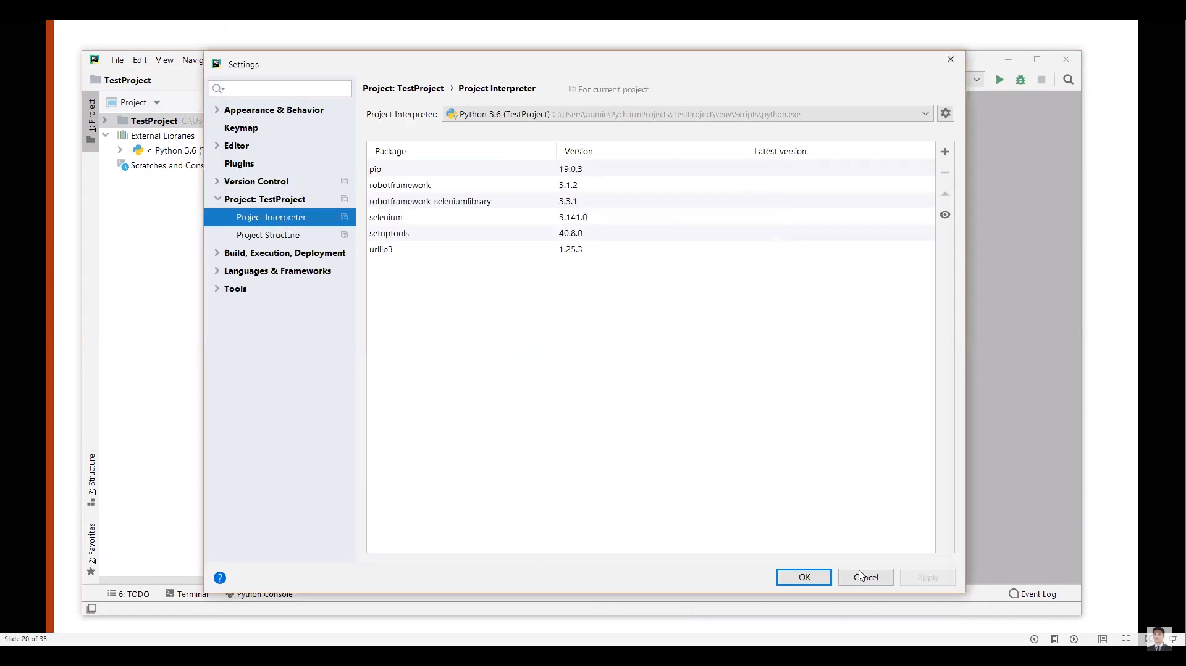

IntelliBotSelenium Library plugin:

To identify the .robot files extension we need IntelliBotSelenium Library plugin and also give auto suggestions for robot framework methods.

File 🡪 Settings 🡪 Plugins 🡪 search ‘IntelliBot @SeleniumLibrary Patched’ 🡪 Install

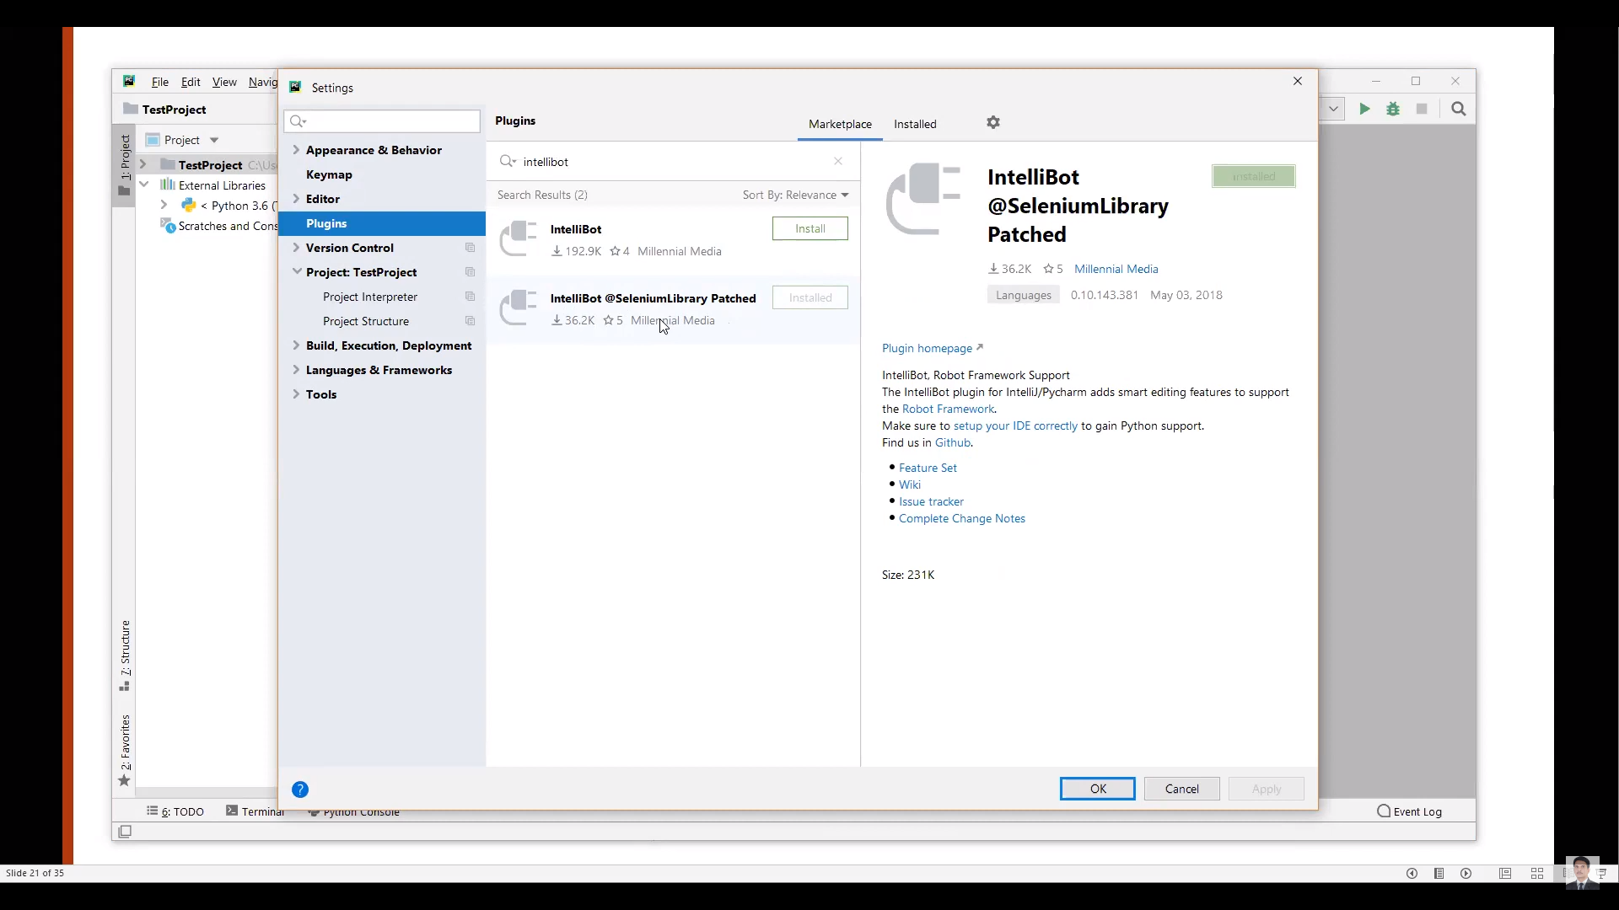

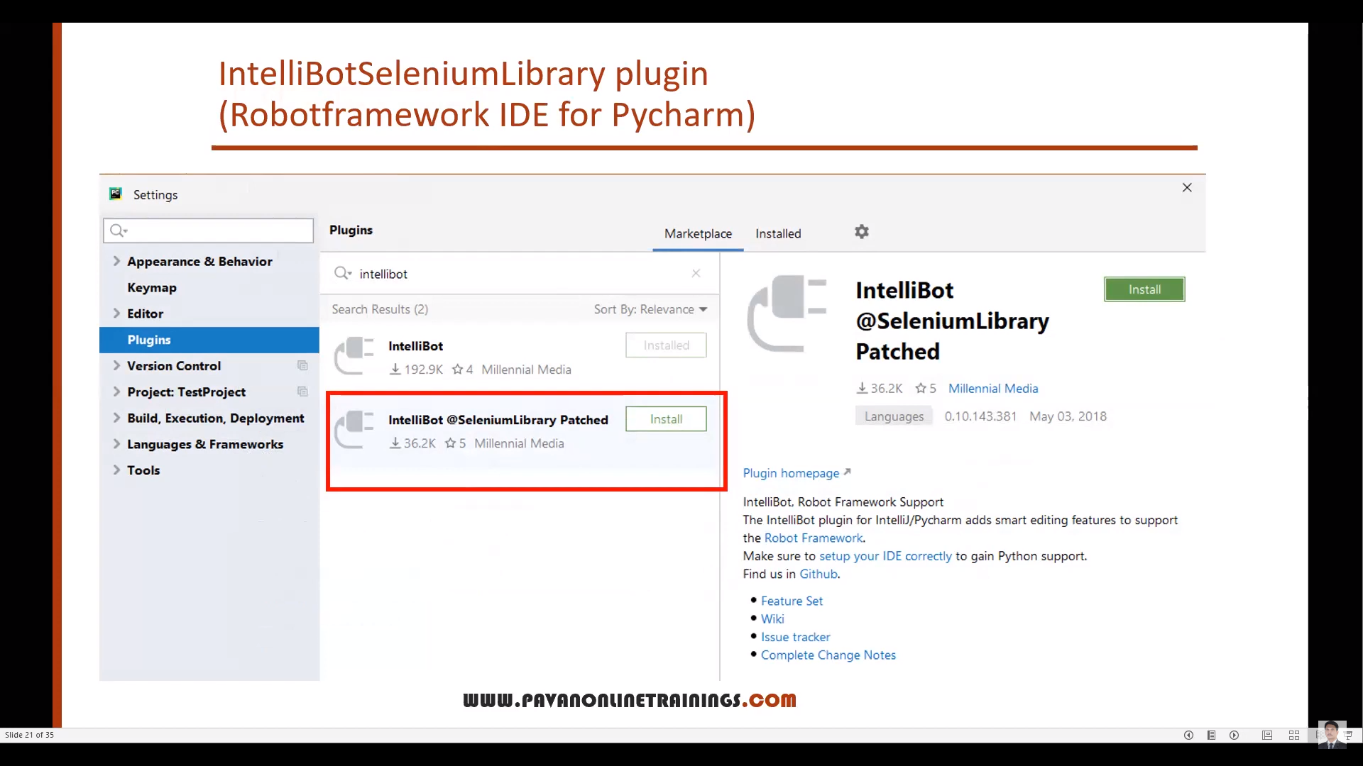

Python selenium scripts and Robot framework scripts:

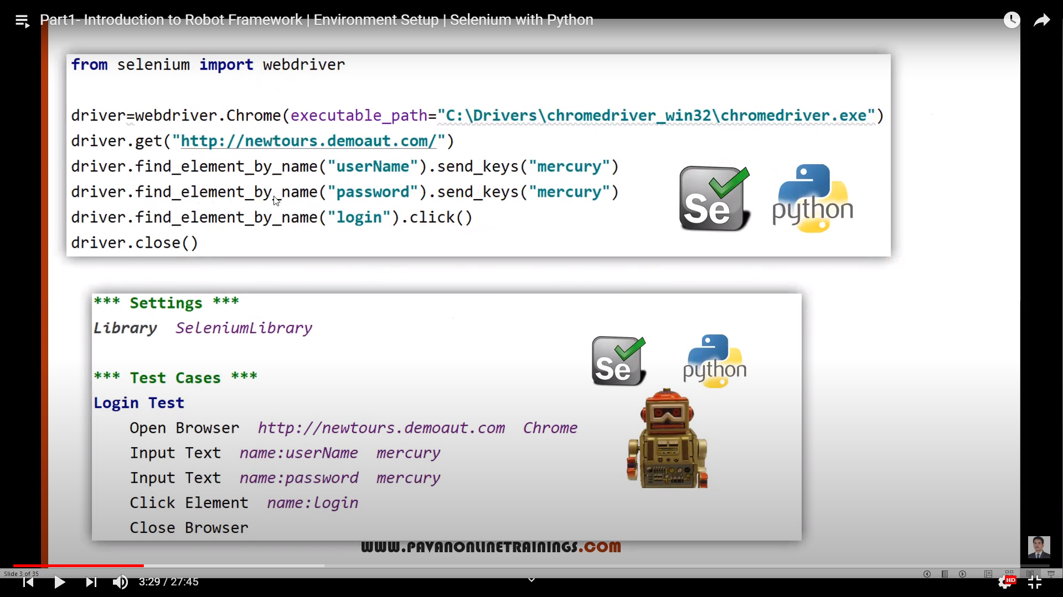

We will use file extensions like:

* Testcase 🡪 .robot
* Excel 🡪 .xls
* Notepad 🡪 .txt
* Python 🡪 .py

